LAB 5

Code:
#include <iostream>
#include <string>
using namespace std;

class Flight {
private:
const int flightNumber;
static string airlineName;
static int totalFlights;

public:
Flight(int number) : flightNumber(number) {
totalFlights++;
}

static int getTotalFlights() {
return totalFlights;
}

static string getAirlineName() {
return airlineName;
}

void display() const {
cout << "Airline: " << airlineName << endl;
cout << "Flight Number: " << flightNumber << endl;
}

~Flight() {
cout << "Flight " << flightNumber << " record has been removed." << endl;
}
};

string Flight::airlineName = "Pakistan International Airlines";
int Flight::totalFlights = 0;

int main() {
Flight f1(101);
Flight f2(202);

f1.display();
cout << endl;
f2.display();

cout << "\nTotal Flights: " << Flight::getTotalFlights() << endl;
cout << "Airline: " << Flight::getAirlineName() << endl;

return 0;
}

OUTPUT:
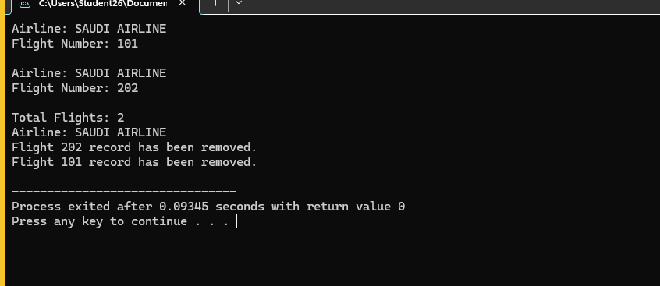

QNO2:

CODE:
#include <iostream>
#include <string>
using namespace std;

class Reservation {
private:
const int roomNumber;
string guestName;
static string hotelName;
static int totalReservations;

public:
Reservation(int room, string guest)
: roomNumber(room), guestName(guest) {
totalReservations++;
}

void setGuestName(string guest) {
guestName = guest;
}

string getGuestName() const {
return guestName;
}

static int getTotalReservations() {
return totalReservations;
}

void display() const {
cout << "Hotel: " << hotelName << endl;
cout << "Room Number: " << roomNumber << endl;
cout << "Guest Name: " << guestName << endl;
}

~Reservation() {
cout << "Reservation for room " << roomNumber
<< " has been cancelled." << endl;
}
};

string Reservation::hotelName = "Pearl Continental";
int Reservation::totalReservations = 0;

int main() {
Reservation r1(101, "Ali");
Reservation r2(202, "Ahmed");

r1.display();
cout << endl;

r2.setGuestName("Ahmed Khan");
r2.display();

cout << "\nTotal Reservations: "
<< Reservation::getTotalReservations() << endl;

return 0;
}

Output: 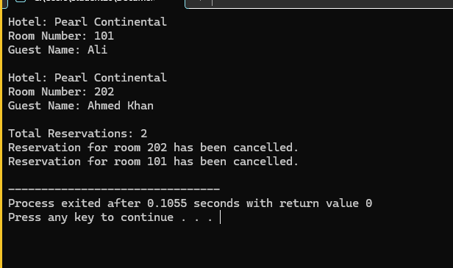

QNO3:

CODE:
#include <iostream>
#include <string>
using namespace std;

class Member {
private:
const int membershipID;
string memberName;
string contactNumber;
static string gymName;
static int totalMembers;

public:
Member(int id, string name, string contact)
: membershipID(id),
memberName(name),
contactNumber(contact) {
totalMembers++;
}

void setMemberName(string name) {
memberName = name;
}

string getMemberName() const {
return memberName;
}

void setContactNumber(string contact) {
contactNumber = contact;
}

string getContactNumber() const {
return contactNumber;
}

static string getGymName() {
return gymName;
}

static int getTotalMembers() {
return totalMembers;
}

void display() const {
cout << "Gym: " << gymName << endl;
cout << "Membership ID: " << membershipID << endl;
cout << "Member Name: " << memberName << endl;
cout << "Contact Number: " << contactNumber << endl;
}

~Member() {
totalMembers--;
}
};

string Member::gymName = "Fitness Arena";
int Member::totalMembers = 0;

int main() {
Member m1(1001, "Ali", "03001234567");
Member m2(1002, "Sara", "03111234567");

m1.display();
cout << endl;
m2.display();

cout << "\nGym Name: " << Member::getGymName() << endl;
cout << "Active Memberships: "
<< Member::getTotalMembers() << endl;

return 0;
}

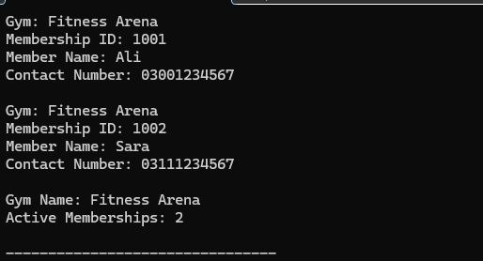

QNO4:
Code:
#include <iostream>
#include <string>
using namespace std;

class Product {
private:
const int productCode;
string productName;
int quantity;
static int warehouseCapacity;

public:
Product(int code, string name, int qty)
: productCode(code),
productName(name),
quantity(qty) {
}

void setProductName(string name) {
productName = name;
}

string getProductName() const {
return productName;
}

void setQuantity(int qty) {
quantity = qty;
}

int getQuantity() const {
return quantity;
}

static int getWarehouseCapacity() {
return warehouseCapacity;
}

void display() const {
cout << "Product Code: " << productCode << endl;
cout << "Product Name: " << productName << endl;
cout << "Quantity: " << quantity << endl;
cout << "Warehouse Capacity: "
<< warehouseCapacity << endl;
}

~Product() {
cout << "Product " << productCode
<< " has been removed from inventory." << endl;
}
};

int Product::warehouseCapacity = 1000;

int main() {
Product p1(501, "Laptop", 20);
Product p2(502, "Keyboard", 50);

p1.display();
cout << endl;
p2.display();

cout << "\nWarehouse Capacity: "
<< Product::getWarehouseCapacity() << endl;

return 0;
}

OUTPUT:
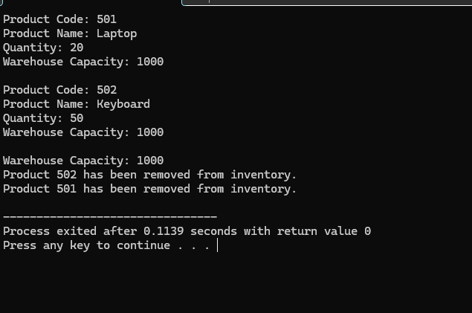

Qno5:
Code:
#include <iostream>
#include <string>
using namespace std;

class Policy {
private:
const int policyNumber;
string policyholderName;
double premiumAmount;
static int totalPolicies;

public:
Policy(int number, string name, double premium)
: policyNumber(number),
policyholderName(name),
premiumAmount(premium) {
totalPolicies++;
}

void setPolicyholderName(string name) {
policyholderName = name;
}

string getPolicyholderName() const {
return policyholderName;
}

void setPremiumAmount(double premium) {
premiumAmount = premium;
}

double getPremiumAmount() const {
return premiumAmount;
}

static int getTotalPolicies() {
return totalPolicies;
}

void display() const {
cout << "Policy Number: " << policyNumber << endl;
cout << "Policyholder: " << policyholderName << endl;
cout << "Premium Amount: " << premiumAmount << endl;
}

~Policy() {
cout << "Policy " << policyNumber
<< " has been closed." << endl;
}
};

int Policy::totalPolicies = 0;

int main() {
Policy p1(10001, "Ali Khan", 25000);
Policy p2(10002, "Sara Ahmed", 30000);

p1.display();
cout << endl;
p2.display();

cout << "\nTotal Policies: "
<< Policy::getTotalPolicies() << endl;

return 0;
}

Output:

